MP0: Event Logging

1. The names and NetIDs of the group members

Xinwei Chen, xinweic2

Hongyi Liu, hongyil7

1. The cluster number you are working on (g36)
2. Instructions for building and running your code. Please include a Makefile if you’re using a compiled language! If there are any libraries or packages that need to be installed, please list those, too. Make sure the instructions are clear; if we cannot run your code we will not be able to give you functionality points.

*Note: we modified the generator.py in its output: changed “%s” to “%.7f” for timestamp output since we found that on the VM the timestamp was printed in two digits after decimal point, which causes the recorded delay to be greatly inaccurate and sometimes negative (oops).*

Since there is no Go (Golang) environment installed on the VM we built the .go files into binaries. Therefore :

**to start the logger,**

*if on a Linux platform, run:*

./mp0-go/logger [port]

*if on a Windows platform, run:*

go run ./mp0-go/logger.go [port]

The port argument is where you specify the port to listen to, default is 9999. You can also specify a log file name after the port argument; otherwise a log file named with the current timestamp will be generated (for analyzing bandwidth and delays).

**to start the event generator and node,**

*if on a Linux platform, run:*

python -u ./mp0-py/generator.py [rate] | ./mp0-go/node [node_name] [address] [port]

*if on a Windows platform, run:*

python -u ./mp0-py/generator.py [rate] | go run ./mp0-go/node.go [node_name] [address] [port]

The rate argument works as explained in the MP prompt. The node_name specifies the name of the node which will be included in the event messages. The address and port arguments should be provided together. Default address and port is 127.0.0.1:9999 which is for local testing only.

1. A description of how you are measuring the delay and bandwidth

We use the difference between the current time the logger receives the event message and the timestamp of the event itself. When a message is received, a timestamp is recorded before the message is parsed so we can calculate the delay as accurately as possible.

$${ΔT= T}_{logger}- T_{node}$$

We use length of bytes the logger received per second to evaluate bandwidth. Each time a message (or sometimes more than one messages) is received from the buffer, we record the bytes read along with the timestamp.

1. Graphs of the evaluation as described above

**Graph1:** Delay of 3 nodes, 0.5 Hz each

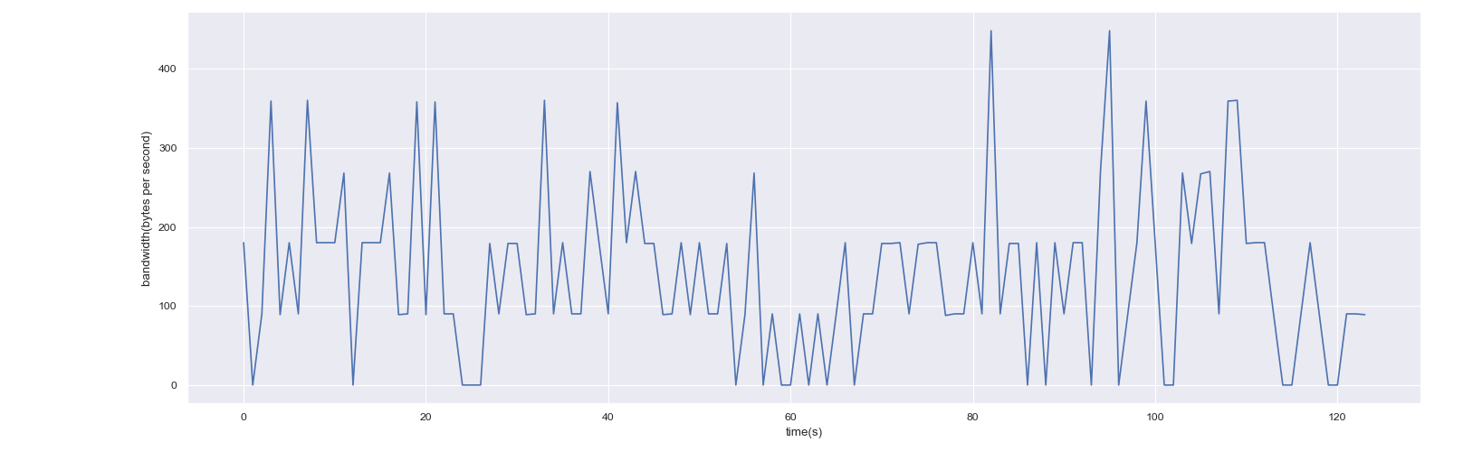

**Graph2:** Bandwidth of 3 nodes, 0.5 Hz each

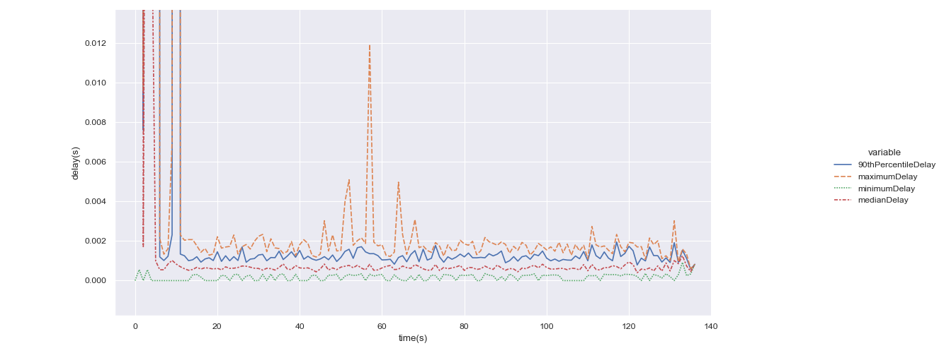

**Graph3:** Delay of 8 nodes, 5 Hz each

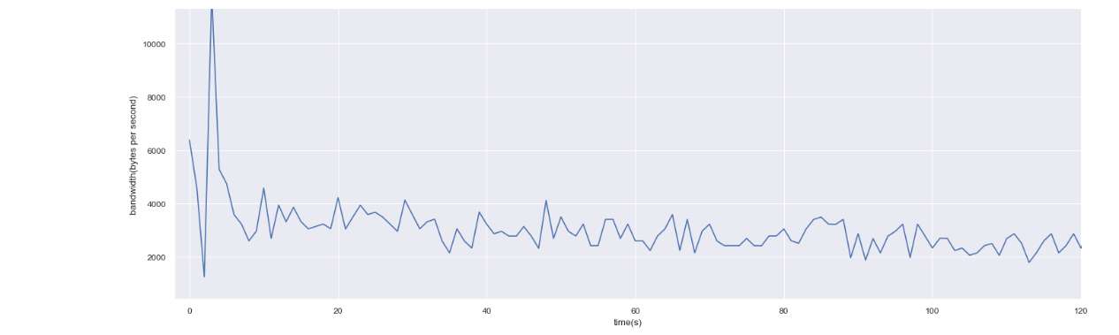

**Graph4:** Bandwidth of 8 nodes, 5 Hz each